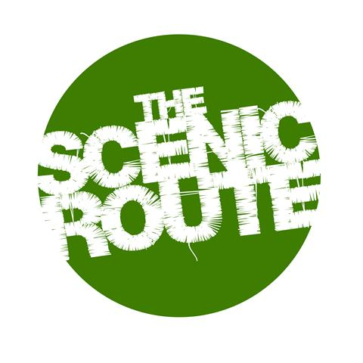
The Lunchbox Booking Form

Please complete and return to info@scenicroutetheatre.co.uk
along with any additional documents / links / files you feel may be useful for us

Please make the payment for your booking via our website to reserve your space in the session

Name:
Date of birth:
Email:
Contact Number:

Session/s Required:
Date:
Date:
Date:

Please let us know what brings you to ‘The Lunchbox’ and what you hope to get out of the session/s
(Please provide as much detail as possible – e.g. your relevant experience, any specific projects you need support with, specific skill sets you would hope to engage with - to help us design the session as effectively as possible)

Where did you hear about ‘The Lunchbox’?

Thank you for your booking. We look forward to working with you at your session.

